Spirituality Policy

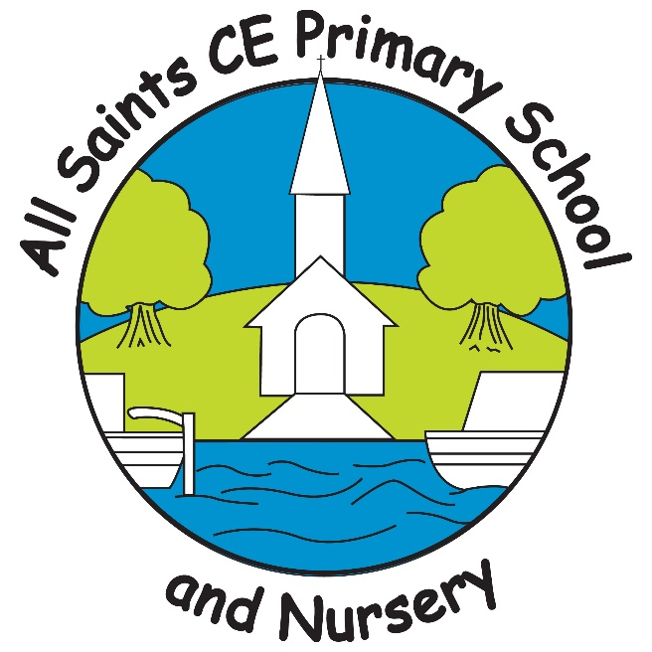

“Learning for life,
building a firm foundation”

Reviewed: October 2023

Headteacher: Lisa Harrison

Signed:

We believe that our vision, Learning for life, building a firm foundation, supports spirituality and spiritual development because we believe that children need firm foundations on which to grow, develop and flourish in all areas of their lives.
At All saints CE Primary School and Nursery, we recognise that developing our pupils’ and adults’ spirituality is an essential element of enabling them to flourish and experience life in all its fullness.

School Statement on Spirituality and Spiritual Development
It can be very difficult to define exactly what spirituality is because it is a unique and personal experience. Different people experience spirituality in different ways and this can change throughout our lifetimes. Spirituality is not the same as having a religion or faith; a person can be spiritual without having a particular faith.
For Christians in church, spirituality is about developing a deeper understanding of and connection with God. It is about God’s way of being with us and our way of being with God. Through this we are able to respond to the loving nature of God as revealed through the Trinity: Father, Son and Holy Spirit. A school is not a church, but it is a collection of people who come from a variety of backgrounds for the purpose of education. Family backgrounds may be very different and spiritual development must take account of the varied circumstances of staff and pupils.
Therefore, in light of this and in light of our school’s distinctively Christian vision, at All Saints CE Primary School and Nursery we provide the following definition of spirituality:
Spirituality is not something that we can see; it is something that we feel inside. It is about the awe and wonder within the world and beyond. It is about asking questions, being inspired and responding to the world and beyond.
At All Saints CE Primary School and Nursery, our vision, Learning for life, building a firm foundation, inspires us to build on the foundations of everything that we experience and learn. This is especially important in our relationships. Our school Christian values of Love, Peace, Hope, Faith and Truth help us to reflect on our relationships and the feelings that they engender within us. For this reason, we have adopted the ‘Relational Consciousness’ model of spiritual development. We, in accordance with our distinctively Christian vision and our school’s definition of spirituality, illustrate what it means to be human through four important relationships.
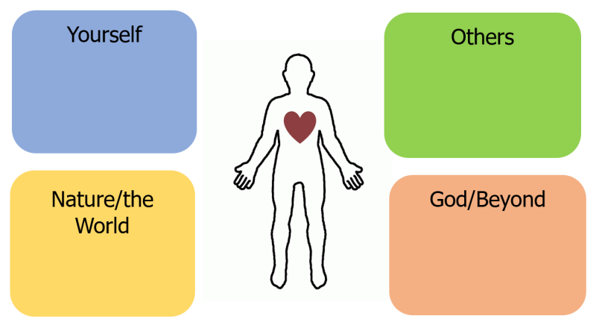

These four important relationships can be defined as:
- Yourself
- Awareness of feelings: ability to reflect and express.
- Awareness of our uniqueness: happiness with who we are.
- Gratitude for the things we have and the person we are.
- Exploration of personal faith.
- Development of imagination and creativity.

- Others
- Empathy and understanding: respect.
- To love and be loved (loving your neighbour).
- Making a difference: duty.
- To live peacefully and seek to reconcile differences.

- Nature/The world
- Developing a sense of awe and wonder.
- Enjoying the miracles of everyday life.
- Taking time for what really matters.
- Appreciating beauty in art, music, nature, etc.
- Seeking ways to be change makers for the world and our environment.

- God/Beyond
- Encountering / experiencing God (having a sense of what lies beyond the material / physical).
- Ability to ask and discuss the ‘Big Questions’ (e.g. about life, death, suffering, nature of God).
- Opportunities for prayer, connecting with God.
- Making sense of the world.

Spirituality and Spiritual Development within the Curriculum
At All Saints CE Primary School and Nursery, we seek to find ways in which all areas of the curriculum can contribute to pupils’ spiritual development. We use our curriculum to plan for age-appropriate and relevant opportunities for pupils to develop spiritually using inspiring topic themes to nurture reflection and thought. For example:
How might scientific discoveries be used for good or evil?
Science

Linking data analysis to ethical issues.
Maths

Using inspirational texts to prompt reflection e.g. War Game – What can we learn about how we want to live?
English

How is silence used to connect with God/beyond?
Religious Education

How does an artist communicate through their work?
Art

Is technological progress always positive?
Design and Technology

Geography
What are our responsibilities as custodians of the world?

What lessons can we learn from a period in time?
History

How do I feel about myself when I exercise?
Physical Education

How does language unite or divide us?
MFL

What do my human relationships mean to me?
PSHE

Spirituality and Spiritual Development within Collective Worship
Collective Worship is special to All Saints CE Primary School. It provides the opportunity for our school community to come together to share experiences, understanding, reflection and understanding.
Collective Worship provides the opportunity for children and adults to become comfortable with reflection and how life in all its fullness provides opportunities to learn from and build foundations upon. It provides a sense of togetherness and a sense of being present when a special experience is shared.
Questioning is used within Collective Worship to encourage thinking and reflection and to invite response. There are times for quiet tranquillity and times for music, stories and prayer. Stories from the Bible are used to inspire spiritual thought and reflection. Where similarities can be found between stories from the Bible and stories from other faiths and traditions, these are used to inspire reflections on all that unites us as humans living together well within our school community.

Spirituality and Spiritual Development within the Daily Life of the School
Opportunities for spirituality are provided at All Saints CE Primary School and Nursery as part of the daily life of the school. Reflection Areas in classrooms provide space, time and resources to support spiritual growth. Our Peace Garden provides a tranquil haven for quiet moments and a connection with nature and the world. During lunchtime playtimes, which are by their very nature noisy and energetic, a calm and peaceful haven can be found in the Reflection Garden for those who seek time to reflect, pray or just to sit with themselves in thought.
Our school Christian values of Love, Peace, Hope, Faith and Truth are discussed frequently with children to nurture an understanding of how these help us to reflect on ourselves, others, the world and beyond.
All Saints CE Primary School and Nursery is an International Cross of Nails School (ICONS) that promotes peace as being central to our relationships with ourselves, others and the wider world. Our ICONS status helps us to make meaningful links between examples of peace and reconciliation in action in the past and our responsibility to live peacefully within a culture of reconciliation and forgiveness now and in the future.

